Steps for end to end text summarization tool

1. Creating a GitHub repository
2. Creating a project template
3. Setting up the project and requirement installation
4. Logging, utils and exception module
5. Project workflows
6. All components Notebook experiment
7. All components modular code implementation
8. Training pipeline
9. Prediction pipeline and user app creation
10. Final CI/CD deployment on AWS
11. Create a new repository on GitHub and copy the link for cloning.
12. Copy this link under HTTPS.

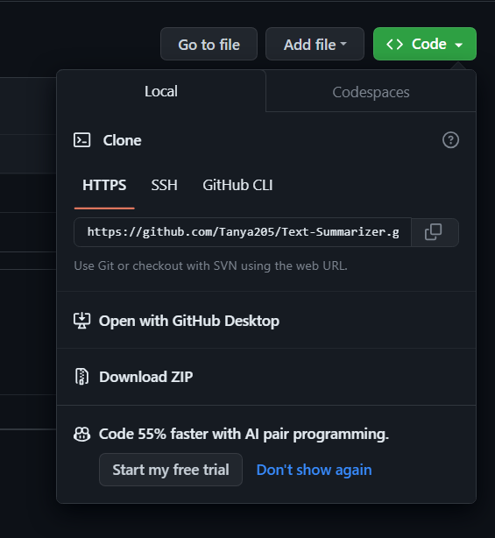

1. To clone the repository in the D drive, Open GitBash. Change directory – $ cd /d/
2. Clone the repository - $ git clone <https://github.com/Tanya205/Text-Summarizer.git>
3. To check the number of files in the cloned folder, first change the directory from D to Text-Summarizer by $ cd Text-summarizer
4. Command for viewing all the files - $ ls